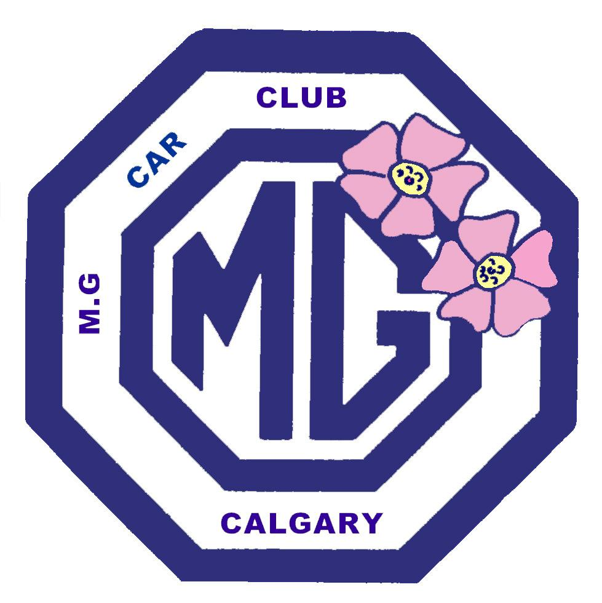 | Calgary MG Car Club  Club Membership Registration Form  www.calgarymgclub.org
For Office Use Only
Please Print all information |  |  |  |  | Reg. Nmbr: |  | Class:
Registrant's Name: |  |  |  | Spouse's Name:
Address:
City: | Province: | Postal Code |  |  |  | Phone #: ( )
E-mail:

Vehicle Information: (if not on file already)
Year: | Make: |  | Model:
Colour: |  | License Plate Number:
Modifications:
Additional Vehicle Information:

Registration Fees:
Yearly Club for 2023 $50 |  |  |  | Registration must be paid by March 31st  Registration includes all vintage vehicles owned by the family.
Total $
Calgary MG Car Club
Westbrooke R.P.O.
Box 34101 Calgary Alberta
T3C 3W2
Please send completed registration forms with a cheque in Canadian funds, payable to “Calgary MG Car Club” at:

Your private information is to be used by the Executive Members of the Calgary MG Car Club. This information will not be used or distributed to anyone outside of the Calgary MG Car Club. The contact information will be distributed by the Executives to the members of the Calgary MG Car Club unless indicated otherwise.

- No, please do not share my personal contact information with the other members of the Calgary MG Car Club
- Yes, it is okay to share my personal contact information with the other members of the Calgary MG Car Club

Please Sign in Agreement: ________________________________________________________



